Profitability and Sales Optimization
GitHub: Profitability and Sales Optimization

Tools: Excel, SSMS, VS Code, Python (Pandas, NumPy, Matplotlib, Seaborn, SQL Alchemy), Jupyter Notebook, Power BI, GitHub, Notion, Draw.io, Power Point, Word.
Project Objective:
Primary Business Objective: Despite high overall order volumes, the company lacks visibility into the true drivers of profitability. The core business objective of this project is to identify the most and least profitable product lines and customer regions to optimize future marketing initiatives and pricing strategies.
Technical Objectives:
- Data Engineering & Consolidation: Develop a modern data warehouse using SQL Server to ingest, clean, and consolidate disparate sales data into a single source of truth for analytical reporting.
- Advanced Analytics: Leverage Python to perform deep exploratory data analysis (EDA) and diagnostic modeling on the warehoused data, transforming raw transactional records into actionable profitability metrics.

Business Questions:
1. Product & Category Profitability
These questions will help identify which products to push in marketing and which to re-price.
- Q1: Which product lines are "Revenue Illusions"? Which product categories or subcategories generate the top 20% of total revenue but fall into the bottom 50% for profit margin?
- Q2: Who are the hidden gems (High Margin, Low Volume)? Are there specific product_names or subcategory items that have exceptional profit margins but low overall quantity sold? (These are prime candidates for marketing boosts).
- Q3: How does product cost impact the bottom line? Is there a correlation between higher product_cost items and tighter profit margins, or are we successfully passing those costs to the customer?
- Q4: Does the maintenance flag/cost cannibalize product profitability? How do products requiring maintenance compare in lifetime profit margin against those that do not?

2. Regional & Geographic Insights
These questions address the "customer regions" part of your problem statement.
- Q5: Which countries are driving true profit? Rank the country column not just by total sales amount, but by average profit margin per order.
- Q6: Are there regional pricing inefficiencies? Do the same product_category items yield drastically different profit margins depending on the country they are sold in? (This suggests a need for regional pricing optimization).
- Q7: Where is our most profitable customer base concentrated? If we map the top 20% most profitable customers, which countries dominate the visual?

3. Customer Demographics & Behavior
These questions help tailor target audiences for future marketing campaigns.
- Q8: profit contribution of top 10% customers
- Q9: Are high-revenue customers actually profitable? Are there customers who spend a lot of total money, but mostly buy low-margin products, resulting in a low true profitability score?
- Q10: Which demographic segment is the most lucrative? By deriving age groups from birthdate, combined with gender and marital_status, which specific cohort yields the highest average profit per customer?
- Q11: Do frequent buyers equal profitable buyers? Is there a correlation between the number of orders a customer places (order_number frequency) and their overall profit margin? Do loyal customers buy high-margin or low-margin goods?

4. Time Series & Operational Efficiency
These questions provide context on when to run campaigns and operational bottlenecks.
- Q12: Are there seasonal profitability dips? Using order_date, what does the month-over-month trend look like for Revenue vs. Profit Margin? Are our highest revenue months actually our least profitable due to heavy discounting?
- Q13: Does shipping lag correlate with specific product lines? What is the average time between order_date and shipping_date for our most profitable vs. least profitable product categories?
Process:
- Dataset: Random Dataset form YouTube (Data with Baraa)

- Notion: For planning, Project Tracking.

- Excel: To understand Data.

- Draw.io: Data Architecture Designs (High-Level Design, Data Integration Design, Data Flow Diagram Design, Data Schema Design) (link)

- SSMS:
- Data Warehousing:
  - Database Creation (link)

  - Bronze layer: (Type: Table)
    - DDL Script Creation. (link)
    - Data Load Procedure. (link)

  - Silver layer:(Type: Table)
    - DDL Script Creation. (link)
    - Data Load Procedure. (link)

  - Gold layer:(Type: View)
    - View Creation. (link)

- Exploratory Data Analysis (EDA):
  - Detailed EDA. (link)
  - Procedure on dimensions and measures Report summary. (link)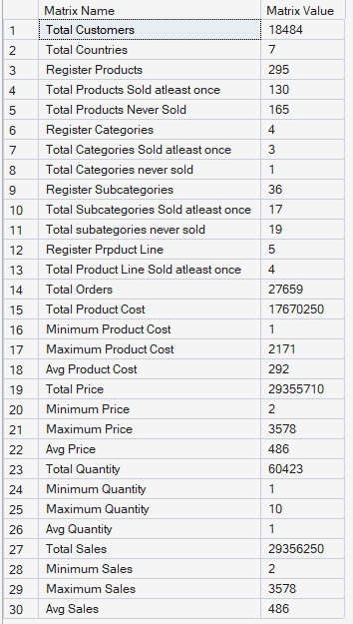
  - Procedure on ranking report summary. (link)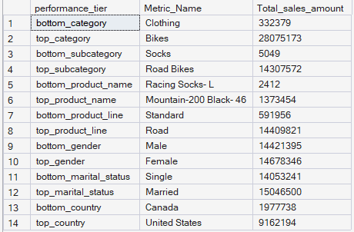

- Python Analysis:(link)
- Importing Modules.
- Connect with SSMS 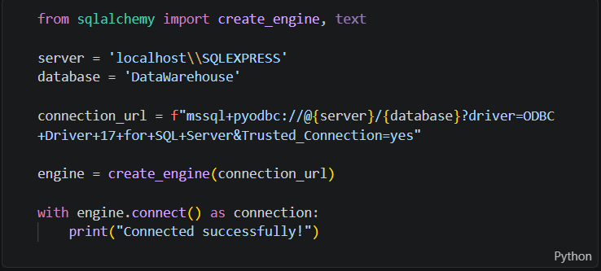
- Fetching Data from SSMS gold layer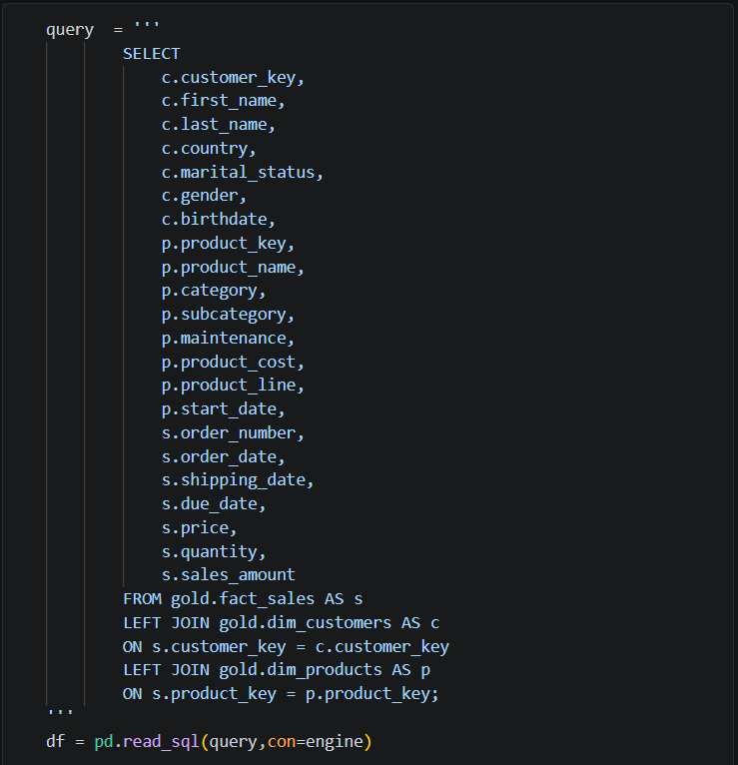
- Data type Validation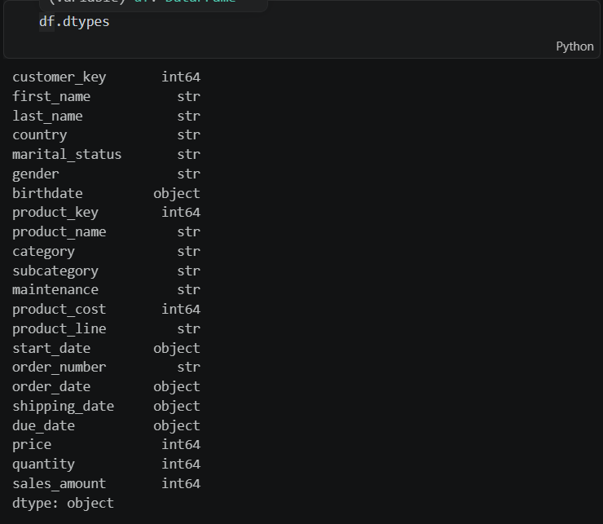
- Date Time conversion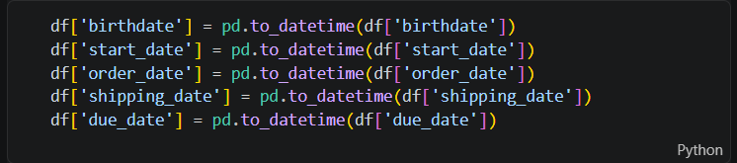
- Feature Engineering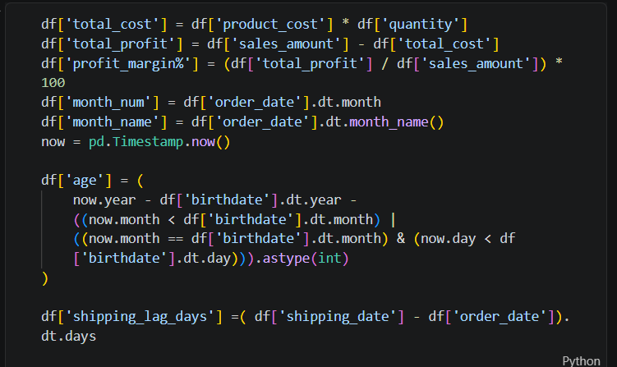
- Business Question Solving.
- Power BI Dashboard (link):
  - Product and Category Profit Dashboard Page.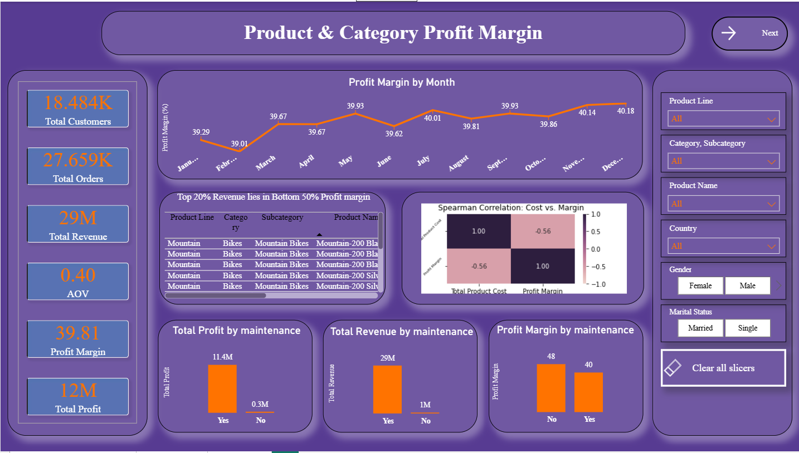
  - Geographic Dashboard Page.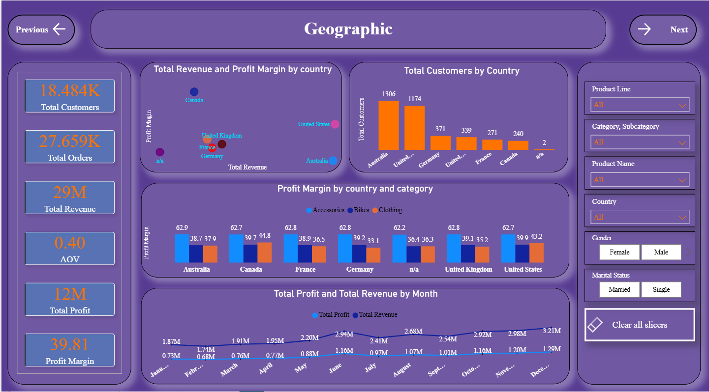
  - Customer Dashboard Page.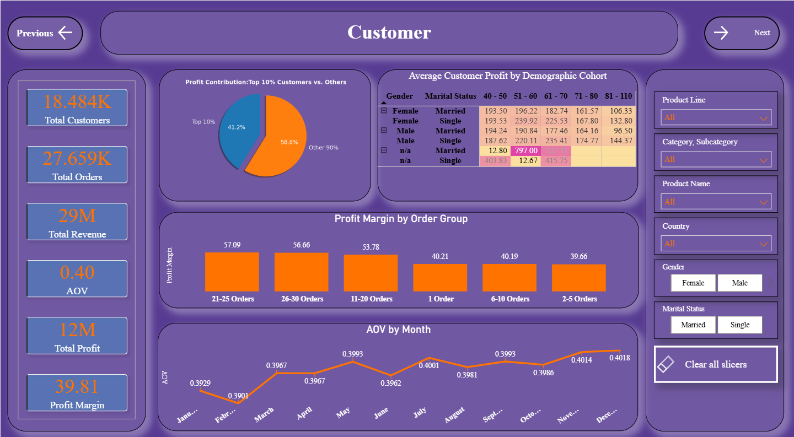
  - Use DAX measures.

    - AOV = [Total Profit] / [Total Revenue]

    - Average Profit = AVERAGEX(fact_sales, [Total Revenue] -RELATED(dim_products[product_cost]))

    - P80 = PERCENTILE.INC(regional_profit_metric[Total_profit],0.80)

    - Profit Margin = ([Total Profit] / [Total Revenue]) * 100

    - Total Cost = SUMX(fact_sales, fact_sales[quantity] * RELATED(dim_products[product_cost]))

    - Total Customers = DISTINCTCOUNT(dim_customers[customer_key])

    - Total orders = DISTINCTCOUNT(fact_sales[order_number])

    - Total Product Cost = SUMX(dim_products,dim_products[product_cost])

    - Total Profit = [Total Revenue] - [Total Cost]

    - Total Quantity = SUMX(fact_sales,fact_sales[quantity])

    - Total Revenue = SUMX(fact_sales,[sales_amount])

  - Create custom columns.
    - Age = DATEDIFF(dim_customers[birthdate],TODAY(),YEAR)

    - Orders Placed = DISTINCTCOUNT(fact_sales[order_number])

    - Age Groups

    - Order Groups

    - Sales Profit Margin = [Profit Margin]

    - Shipping Lag Days = DATEDIFF(fact_sales[order_date],fact_sales[shipping_date],DAY)

  - Create custom Tables.
    - 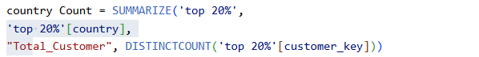
    - 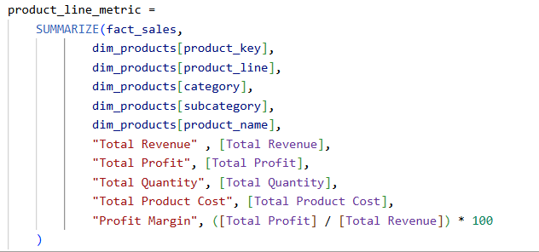
    - 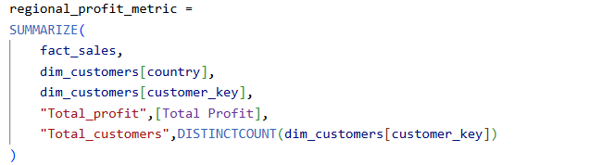

  - Used Python scripts to create visuals.
    - 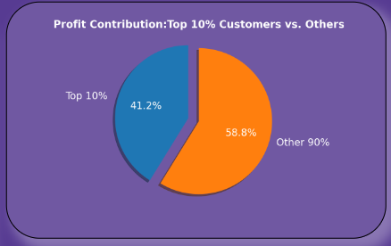
Code
import pandas as pd
import matplotlib.pyplot as plt
import seaborn as sns

top_customers = dataset.sort_values(by='Total Profit', ascending=False)
overall_profit = dataset['Total Profit'].sum()
top_10_per_count = int(len(top_customers)* 0.10)
top_profit_sum = top_customers.head(top_10_per_count)['Total Profit'].sum()
top_10_profit = top_customers.iloc[:top_10_per_count]['Total Profit'].sum()
others_profit = top_customers.iloc[top_10_per_count:]['Total Profit'].sum()

labels = ['Top 10% ', 'Other 90%']
sizes = [top_10_profit, others_profit]
explode = (0.15, 0)
plt.figure(figsize=(10, 8), facecolor='none')
plt.pie(sizes, explode=explode, labels=labels,autopct='%1.1f%%',shadow=True, startangle=90,textprops={'color': 'white', 'fontsize': 24})
plt.title('Profit Contribution:Top 10% Customers vs. Others', fontsize=25,pad = 0,color = 'white', fontweight = 'bold')
plt.show()

    - 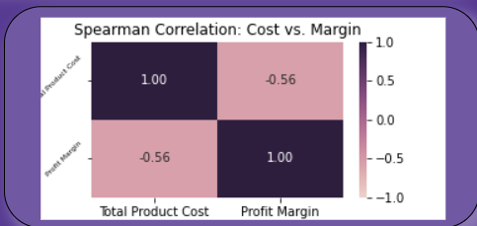
Code:
import matplotlib.pyplot as plt
import seaborn as sns
import pandas as pd

correlation_metric = dataset[['Total Product Cost','Profit Margin']].corr(method='spearman')
plt.title('Spearman Correlation: Cost vs. Margin')
sns.heatmap(correlation_metric, annot=True, fmt = '.2f', vmin=-1, vmax= 1, cmap=sns.cubehelix_palette(as_cmap=True))
plt.yticks(rotation=45,fontsize = 6)
plt.show()

  - Page navigation.

- Power Point: For Presentation.
- Word: For Documentation.
- GitHub: To showcase Project.

